
Noc-Dashboard
User Demo Guide

Issue | 1
Date | 2026-08-28
Prepared By | Noc-Dashboard Engineering

NOC-DASHBOARD
NOC-DASHBOARD ENGINEERING

Contents
Right-click here and choose Update Field to build the Table of Contents.

1 Getting Started
This chapter is a quick tour of the dashboard's shell — the parts that stay on screen no matter which page you're on.

1.1 The Dashboard Shell
There is no login step — opening the dashboard's URL goes straight to live data. Every page shares the same sidebar and topbar shown below; the full topbar toolbar is covered in detail in Chapter 2.
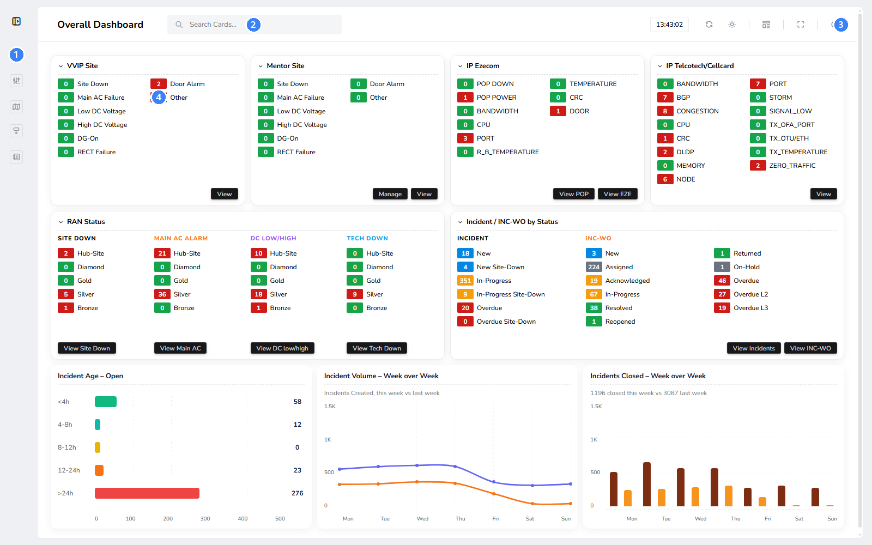
1. Sidebar — Switches between the five pages: Overall Dashboard, Custom Dashboard (Reports), Map View, Mentor Site, and Partner Contact. RAN Status is a section within the Overall Dashboard, not a separate page.
2. Search Cards — Type to jump straight to any card on the current page by name — works on both the Overall and Custom Dashboard.
3. Help — Opens this guide's live counterpart inside the app, any time, from any page. See Chapter 8.
4. A card badge — Every colored number is a live count. Click any one — the label, the number, or the bar/dot next to it — to open its filtered drilldown table.

2 The Topbar Toolbar
Five icons sit at the top right of every page: Refresh, Theme, Card Layout, Fullscreen, and Help. This chapter covers the first four in detail.

2.1 Refresh & Search
The toolbar's leftmost two icons are the simplest.
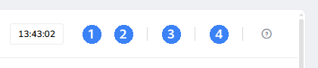
1. Refresh — Reloads the current page. Background sync jobs keep the local cache fresh every few minutes on their own — this is only for pulling that latest cache state onto the screen immediately instead of waiting for your next natural page load.
2. Theme — Opens the Light/Dark dropdown — see Section 2.2.
3. Card Layout — Opens the layout settings for dashboard cards — see Section 2.3.
4. Fullscreen — Toggles the browser's fullscreen mode. The icon itself swaps between expand and shrink arrows to reflect the current state.

2.2 Light & Dark Mode
Click the Theme icon to open a small Light/Dark dropdown. The choice is saved in the browser and applied instantly, with no page reload.
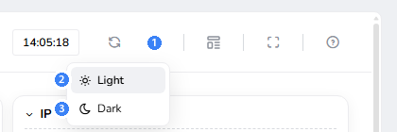
1. Theme icon — Shows a sun in light mode, a moon in dark mode — always reflects the currently active theme, not just a static icon.
2. Light — Switches to the light theme shown throughout the rest of this guide.
3. Dark — Switches to the dark theme — every page, chart, and table restyles to match, shown below.
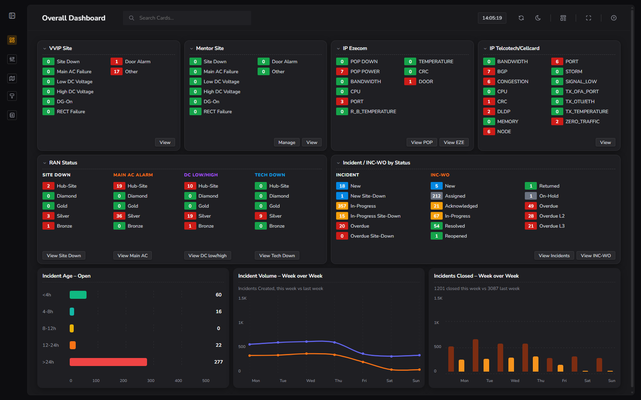
Figure 2-1 The Overall Dashboard in Dark mode — every card, chart, and badge color carries over unchanged; only the surrounding surface and text colors invert.

2.3 Card Layout (Custom Template)
The Card Layout icon opens a modal for choosing how dashboard cards are arranged — independently for the Overall Dashboard and the Custom Dashboard (Reports).
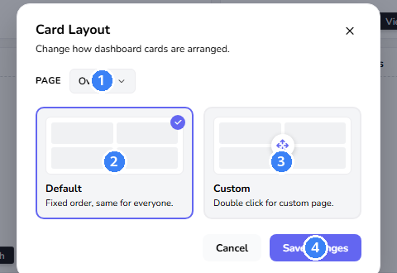
1. Page — Choose which page this layout choice applies to — Overall or Custom — independent of which page you're currently viewing.
2. Default — Fixed card order, the same for everyone. This is what every screenshot in this guide uses.
3. Custom — Double-click to open the bigger Arrange Your Cards overlay, where every card on the chosen page appears as a draggable placeholder — drag to reorder, then Save changes to apply it live.
4. Save changes — Applies the selected mode. Saved per page, per browser (localStorage) — it doesn't change what other users see.
- Card visibility itself (which cards exist at all) is controlled separately by an administrator via FEATURE_* flags — Card Layout only controls order, not which cards are shown.

3 Dashboard
The Overall Dashboard is the default landing page — a single screen of live badge counts and trend charts.

3.1 Reading the Dashboard
Each card groups related alarms or incidents by severity/grade. RAN Status and Incident/INC-WO by Status each carry several independent badge groups side by side, each with its own View button.
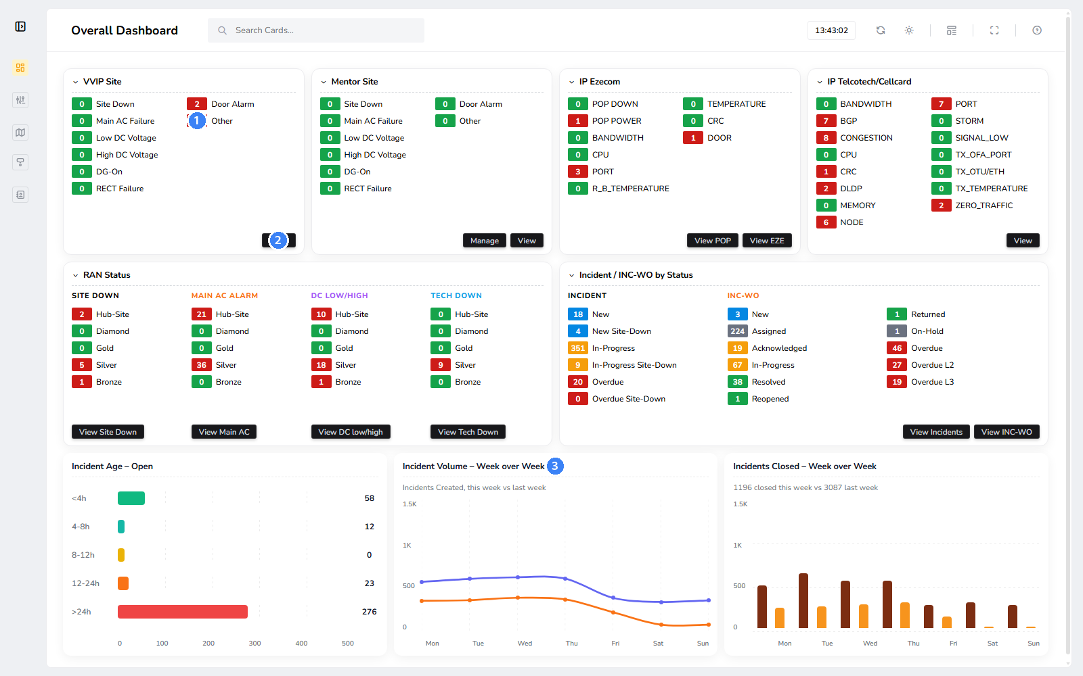
1. Badge count — A live count for one alarm type at one grade — 0 is healthy, any other number needs attention.
2. View — Opens the full drilldown table behind this card, with its own date/category filters and CSV export.
3. Incident Volume — Week over Week — One of three chart cards; see Section 3.2 for how to read and click into these.
- RAN Status has four independent badge groups (Site Down, Main AC Alarm, DC Low/High, Tech Down), each with its own View button below it.
- Incident / INC-WO by Status has two badge groups (Incident, INC-WO) sharing one row, each with its own View button.

3.2 Chart Interactivity
All three chart cards (Incident Age, Incident Volume, Incidents Closed) behave like an extension of the badge system above — every bar, dot, and segment is clickable, and hovering shows a detail tooltip first.
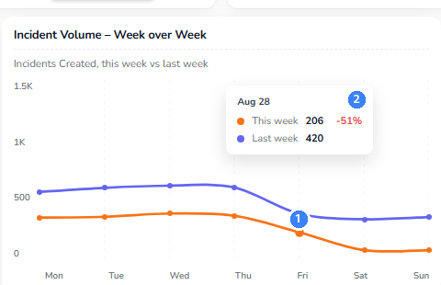
1. A data point — Hovering over any dot (Incident Volume) or bar (Incidents Closed) — or any bar/label/count on Incident Age — shows its exact value before you click anything.
2. Hover tooltip — Shows the date, this week's and last week's values side by side, and the percentage change between them — computed fresh on every page load, always Monday-Sunday.
- Clicking a data point (not just hovering) opens the same kind of filtered drilldown table as clicking a badge elsewhere in the app — e.g. clicking Friday's "This week" dot opens every incident created that specific day.
- Incident Age – Open works the same way but as horizontal bars — click the age-bucket label, its bar, or its count to drill into incidents open that long.

4 Map View
The Map plots every On-Air, Planned, and Other site, plus every ISP POP, on an interactive map of the network.

4.1 Using the Map
The screenshot below is zoomed to one illustrative area of the network rather than the full national view.
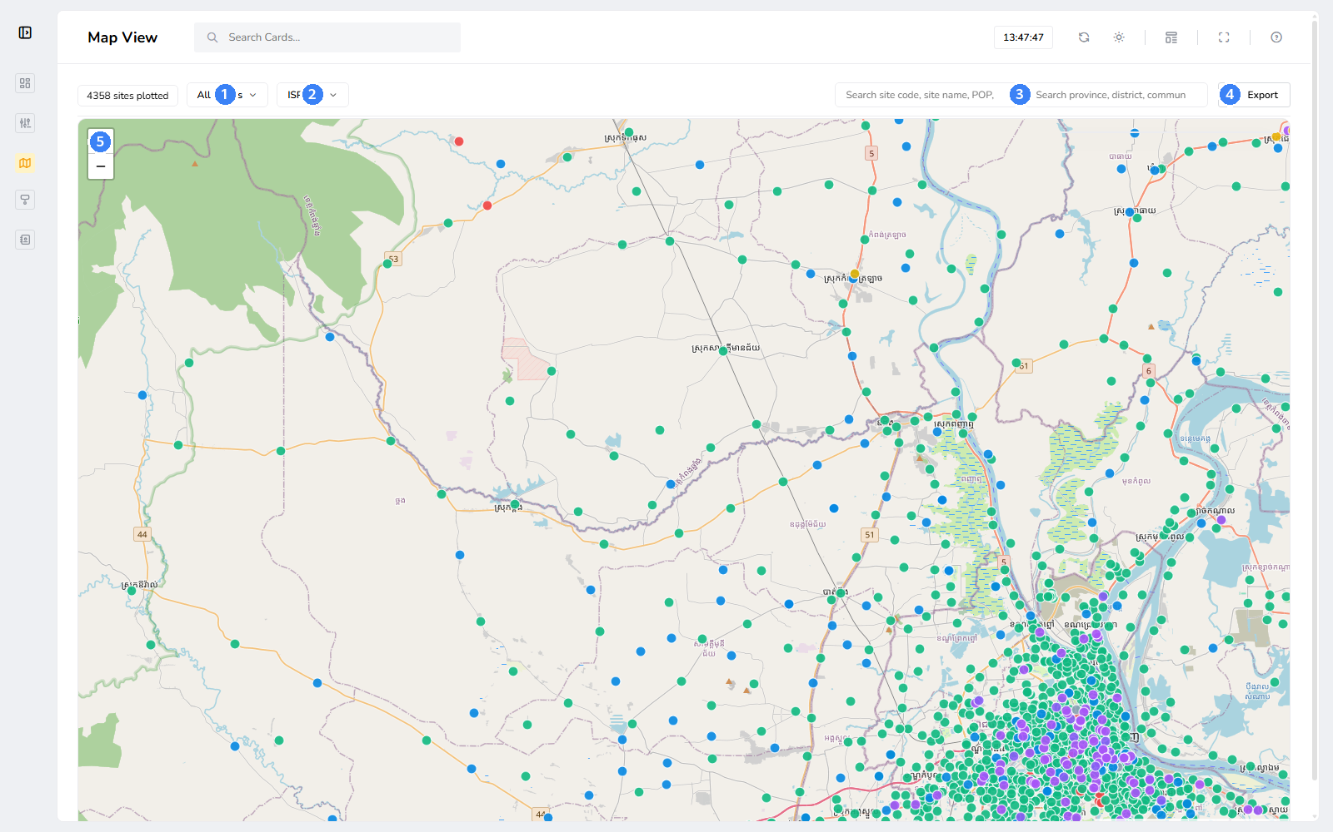
1. Status filter — Switch between On Air, Planned, Other, and Site Down, or a specific vendor under On Air.
2. Site-type filter — Switch between ISP sites and POPs.
3. Search boxes — Search by site code, POP code, or village name, or by province/district/commune to draw a scoped boundary.
4. Export — Download a styled .xlsx of whatever is currently shown or scoped.
5. Zoom controls — The map also responds to scroll-to-zoom and refreshes itself automatically in the background.
- Clicking any site or POP dot opens a popup with its name, status, and — for a site with an open Site Down incident — a warning banner plus a direct link to that incident.

5 Partner Contact
A directory of partners and their escalation contacts, backed directly by MSSQL.

5.1 Managing Partners
Partner names, contact names, and circuit details are blurred below since this guide is illustrative; the real page shows full records.
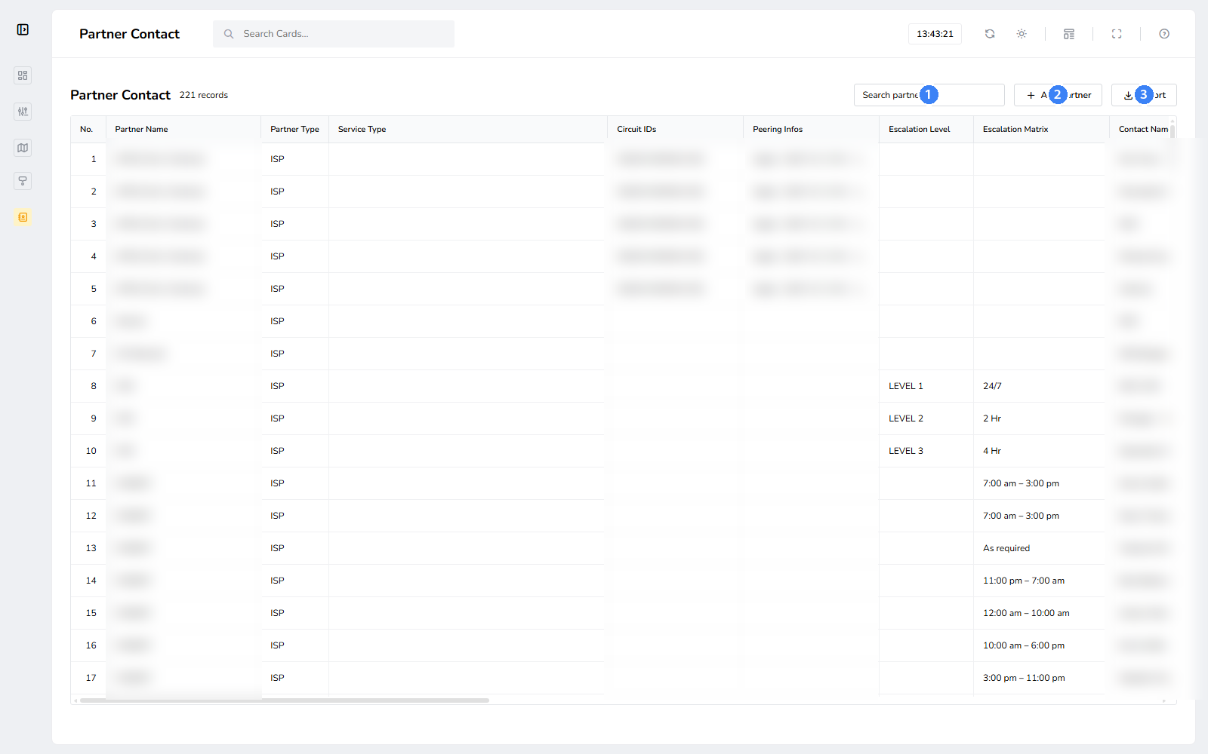
1. Search partners — Filter the list by partner name as you type.
2. Add Partner — Create a new partner together with its first contact in one step.
3. Export — Download a styled .xlsx of the current partner list.
- Each row's Add Contact button attaches another contact to an existing partner — this never creates a duplicate partner record.
- Each row's Manage Circuits button opens a dedicated page to add, edit, or remove that partner's circuits.

6 Reports
The Custom Dashboard combines several related cards into one page for a single consolidated export.

6.1 Custom Dashboard
Each card behaves exactly like a card on the Overall Dashboard — a live badge count with its own View button and drilldown — including the same Refresh, Theme, Card Layout, and Fullscreen toolbar from Chapter 2.
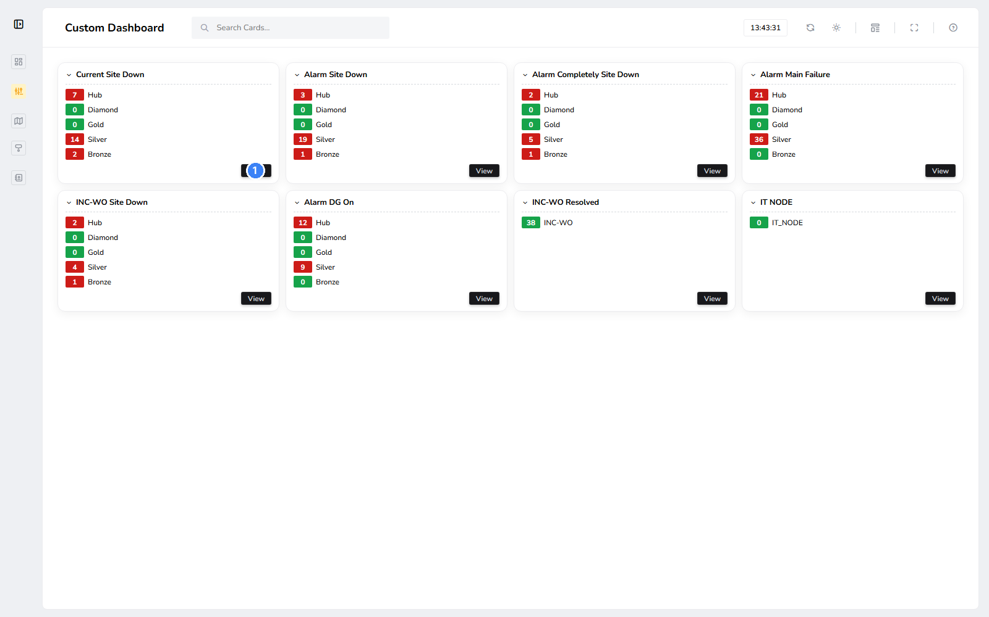
1. View — Opens this card's drilldown table, same as on the main Dashboard.

7 Mentor Site
Mentor Site lets a NOC engineer flag specific sites for focused monitoring, independent of their normal status.

7.1 Configuring Mentor Sites
Sites can be added one at a time or in bulk from a CSV file.
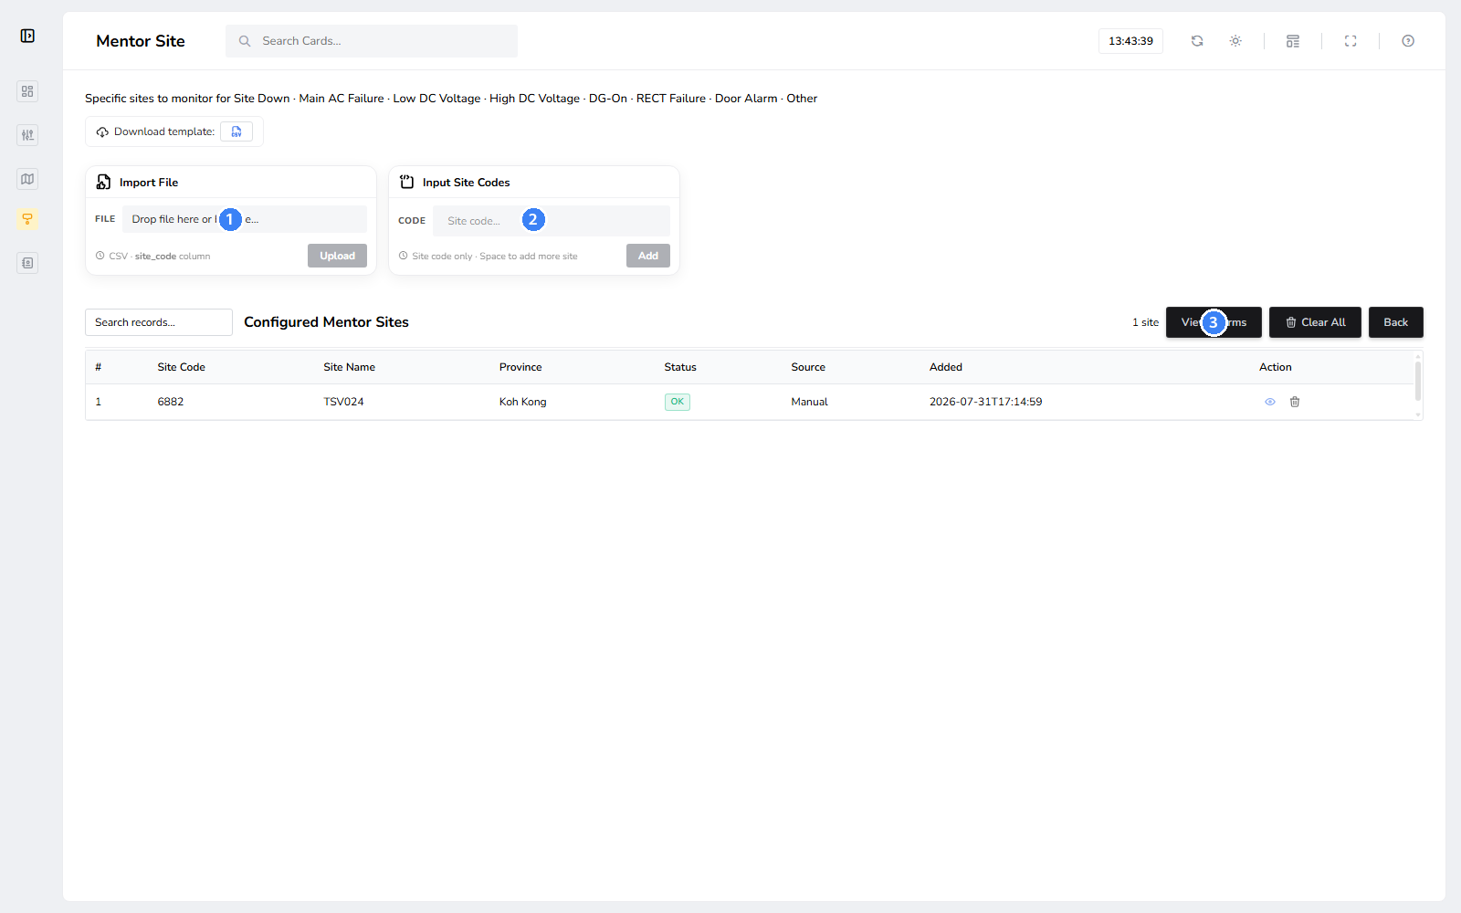
1. Import File — Bulk-add sites from a CSV with a site_code column.
2. Input Site Codes — Add one or more sites by typing their codes directly.
3. View Alarms — Opens the alarm drilldown scoped to only the configured mentor sites.

8 Getting Help
Every page's topbar carries a Help icon that opens this same walkthrough inside the running application.

8.1 The Help Page
The Help page stands alone — no sidebar or topbar — so it never gets in the way of the page you came from.
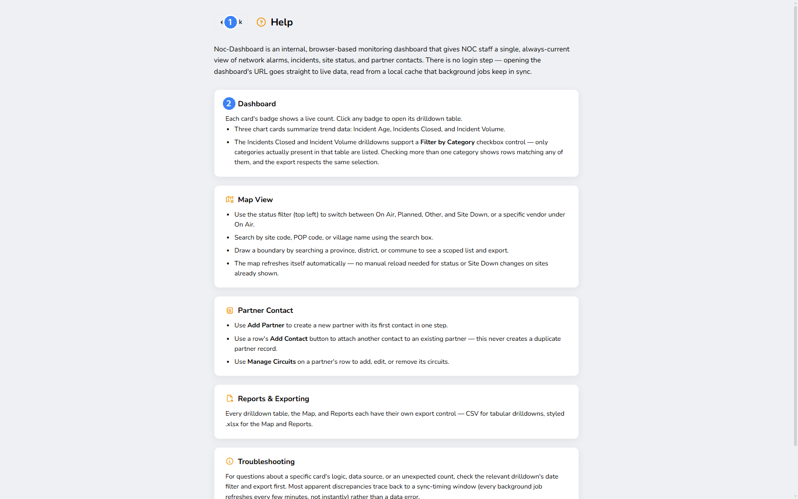
1. Back — Returns to whichever page you opened Help from.
2. Section cards — One card per area of the app, each summarizing that page's controls.

